Human Resources: ATG Performance Review Process

**Objective/Purpose/ Why:** It is critical to Alliance’s success that every employee works toward meeting our business goals. Our **Performance Review Process** is one tool used by the company to ensure that individual employee goals and objectives are aligned with the overall strategic plan. ATG’s Performance Review period is 12 months beginning each October and running through September of the following year.

**Outcome:**

* Our Performance Review Process is one tool used by the company to ensure that individual employee goals and objectives are aligned with the overall strategic plan. Each employee should set no fewer than 3 Qualitative goals, but no more than 5.

**Subject Matter Expert:**

* Human Resources Director and Generalist(s)

**Process:**

ATG Performance Review Process: 3 Phases

* Introducing the Review process in 3 Phases
* Note: If you were hired on or after August 1, you will skip the “Perform Phase” and start participating in the “Plan Phase” immediately following ATG’s September Evaluations.

**“PLAN”** Phase - Goal Setting (September/October, or within 30 days of initial start date)

“**PROGRESS**” Phase - Midpoint check-in (April/May, or more often if necessary)

“**PERFORM**” Phase – the formal Annual Performance Review (September/October). This is completed via the following steps:

1. Employee submits a self-evaluation.
2. Supervisor reviews, suggests edits.
3. Formal Discussion between employee and supervisor. Consensus/approval by supervisor.
4. Practice lead/Division Lead review/approval.
5. Submission to HR.

* **NOTE:** This Document is broken up into Plan, Progress and Perform for both Employees and Supervisors and Leads.

1. Login

* Log into ATGHR using your Microsoft login.
* **NOTE:** Google Chrome is the preferred browser. If you encounter a security warning when you click on the link, you should reboot your PC and try again. Contact DSA ([datasystems@emailatg.com](mailto:datasystems@emailatg.com)) with any persistent security warnings, bugs, or other issues within the application.) You must be connected to the ATG VPN to access ATGHR from a remote location.



PLAN Phase: Goal Setting

Quantitative Goals:

Numerical goals (UT, Job Starts, Multiplier, etc.) Some are “individualized”, some are determined by the Company’s annual Business Plan.

Qualitative Goals

3 – 5 non-numeric goals covering:

1. Professional Development
2. Technical Development
3. Marketing/Business Development
4. etc.

To be most effective, Qualitative goals should be developed using the SMART method:

* **S –** Specific, clear, and well-defined
* **M –** Measurable results.Precise outcomes that are expected
* **A –** Attainable results. Bar is high, but not too high
* **R –** Relevant to your career “trajectory”
* **T –** Time Bound. Your goal has a deadline

PLAN Phase: ATGHR for All Users

1. Review current or previous Goals.

* Click on the view button to access your Goals.
* Click the “view” button to review current or previous goals.

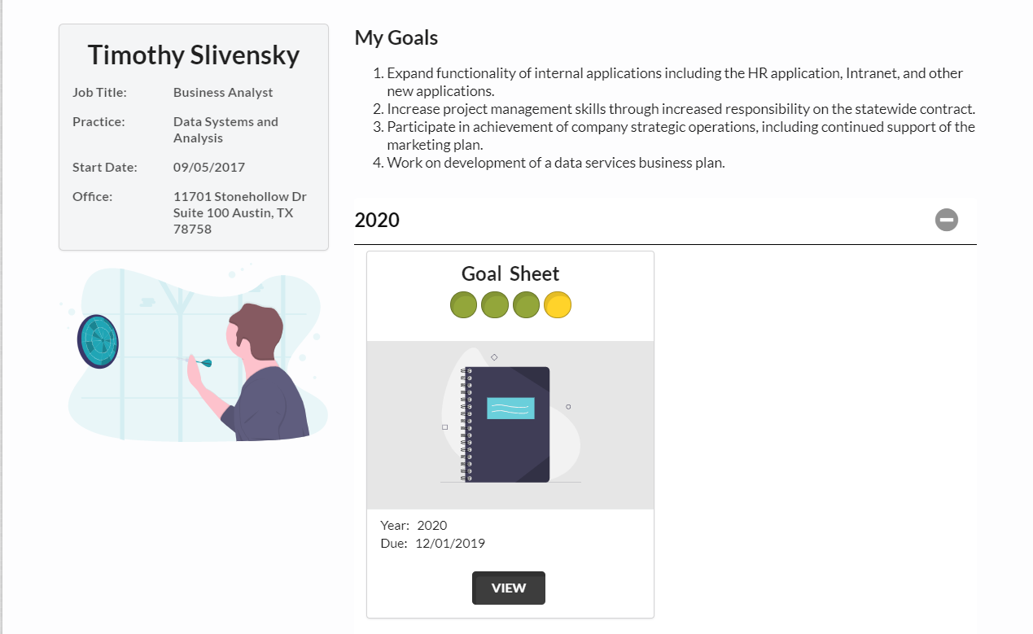

2. Review & Execute Each Tab: Company, Quantitative, Qualitative

* Three tabs are addressed in the annual performance review. You may review these tabs at any time throughout the year.
* Company Goals
* Company Goals are pre-filled and illustrate annual goals based upon the company’s annual business Plan. Do not Change anything.

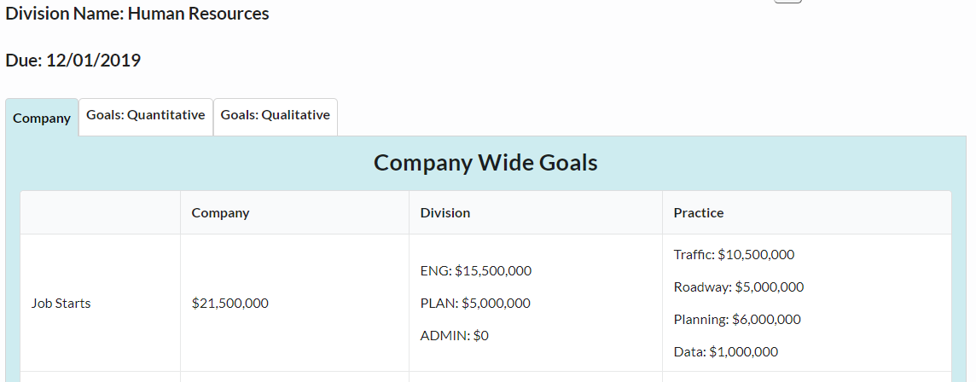

* Goals: Quantitative
* Some numerical goals (including UT and MUT) are pre-determined for each employee based upon the company’s annual business plan. Others (including Job Starts) are set based upon a conversation with your supervisor and/or Practice/Division Lead
* You may set a goal of a higher quantity than those projected and record your updates in the “Employee Input” box. You may comment by clicking on the “Discussion” and “Add Comment”.
* **NOTE:** Hit “Save” regularly to secure added content and avoid window time-out.

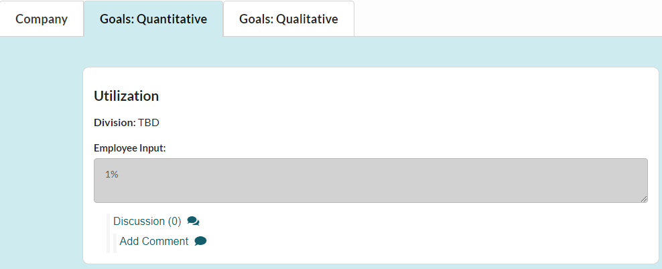

#%

* Goals: Qualitative
* Employees should set no fewer than **3** Qualitative goals, but no more than **5**. Each of the goals can be independently weighted to reflect their importance compared to the others (the total must add to 100%). You and your supervisor will agree to this weighting.
* For each goal, set your due date and weight of importance. You will record your goal in the “Employee Input” box.
* To complete each goal, you must elaborate by executing each of the employee input boxes on the details drop-down list:

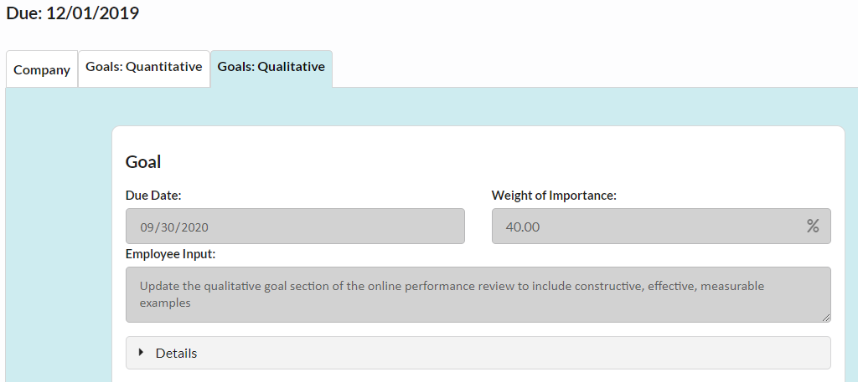

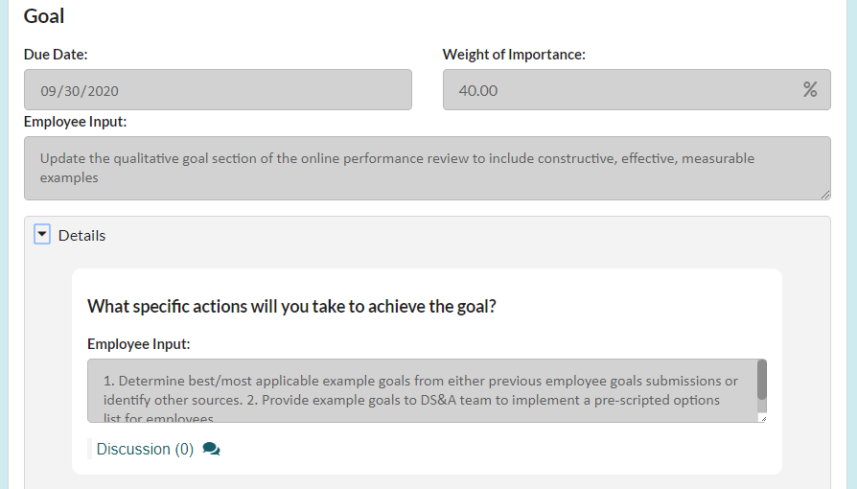

3. Suggested Goals

* ATG has selected several quality goals from previous years that relate to your role. These goals will help you formulate goals for the performance year.
* To add a suggested goal, click the “View” button, and a pop-up will appear.
* Select a Goal from the drop-down and click “Assign”. The goal is now assigned. You will still need to complete the details section of the goal.

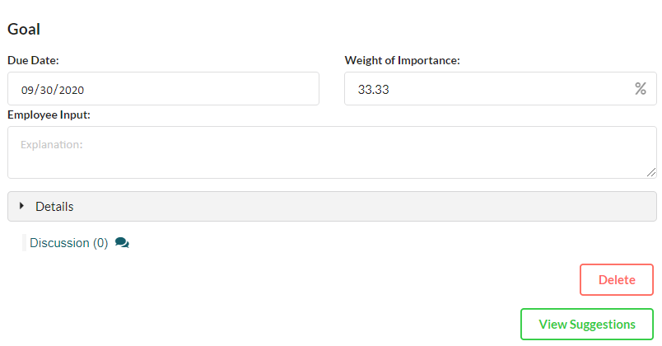

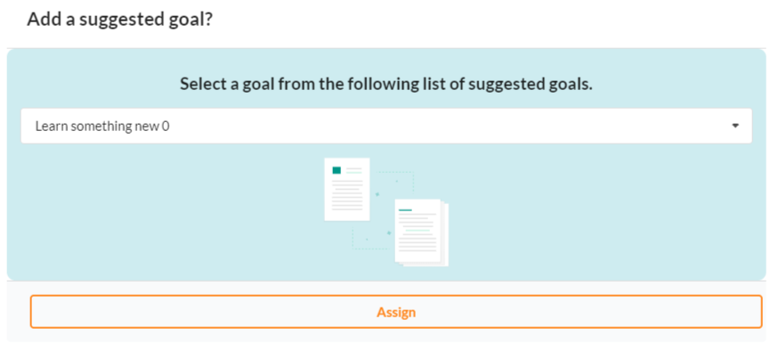

4. Execute Goals, click “Save” and “Submit”

* When you submit your goals, the first circle in the progress bar will turn green.
* Your supervisor will be notified by email upon your submission.
* There are 3 approvers in the process, Supervisor> Lead> HR. For each stage of approval, the progress bar will turn green upon completion.
* **NOTE:** As the “owner” of your goals, ONLY YOU can make edits to your goals. Approvers are limited to providing information within the ‘Discussion’ boxes only



PLAN Phase: ATGHR for Supervisors and Leads

1. Reviewing Employees Goals

* Click on the “Manage” drop down and select “Goals”.
* Note: Goals that have not been approved by HR are listed under “Active Goals.”
* Note: Goals that have been approved by HR during the current PLAN & PROGRESS phases are listed under “Approved Goals”

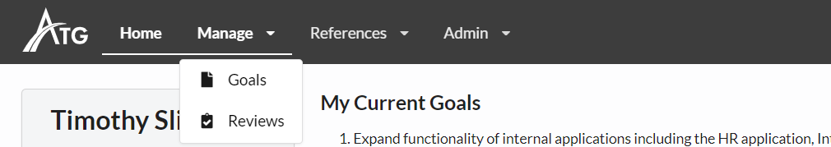

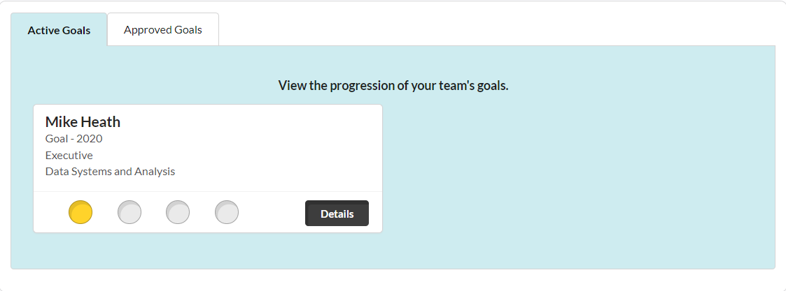

2. Returning an Employee’s Goals for Edits

* If you disagree with the goals set by the employee, supervisors/Leads/HR may opt to “send back to employee”. When the goals are sent back, the progress bar goes back to yellow, and the employee will be notified their goals were returned. You should provide information to the employee about how to modify their goal.



3. Approving an Employee’s Goals

* If you approve of the goals, click “Approve (by supervisor/Lead).” This will advance the goals to its next required approval.



PROGRESS Phase

* Midway through the review period (or more often if needed, employee’s ad their supervisor meet to review progress made towards achieving the goals set during the Plan Phase. If necessary, goals may be amended, replaced, or otherwise modified based on new information, updated priorities, changing business conditions, etc.

PROGRESS Phase: ATGHR for All Users

1. Reviewing Goals

* Click the “View” button to review your goals you set during the PLAN Phase.



2. Edit your Goals

* If you would like to make changes, click the “Take Back for Edits” button in the top right corner of the screen.
* **NOTE:** Taking back Goals for edits will reset all the approvals of the goals. Your goals will need to be approved again by your Supervisor, the Lead, and by HR.
* **NOTE:** If you have an approved change to your UT goal, please contact HR, and they will make that change.



3. Execute Goals

* Click “Save” and “Submit”
* When you submit your goals, the first circle in the progress bar will turn green.
* Your supervisor will be notified by email upon your employee’s submission.
* There are 3 approvers in the process, supervisors, leads, and HR. For each stage of approval, the progress bar will turn green all the way the chain.



PROGRESS Phase: ATGHR for Supervisors and Leads

1. Reviewing Goals

* Click on the “Manage” drop down and select Goals. Your user profile will offer several drop-down items.



2. Approved Goals

* Goals that have been approved by HR during the current PLAN & PROGRESS phases are listed under “Approved Goals”.
* You can review them by clicking the “View” button in the table.

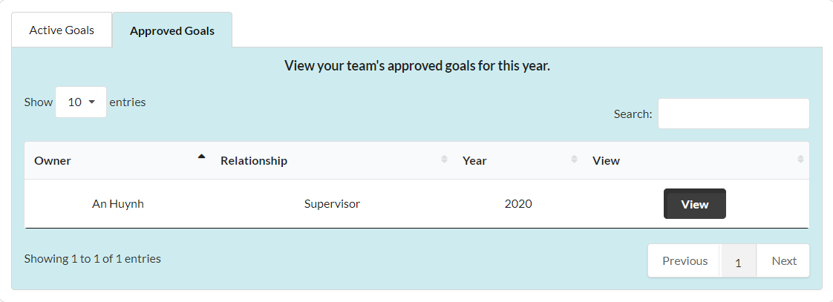

3. If your employee “Takes Back for Edits”

* If your employee takes back their goals for edits, those goals will show up under the “Active Goals” tab.



PERFORM Phase: The Annual Performance Review

5 Performance Review ‘Sections’

The Performance Review document is divided into 5 sections:

1. Quantitative (numerical) Goals
2. Qualitative Goals (areas of growth - Technical, Professional, Marketing/BD…)
3. Core Job and Leadership Competencies
4. Role Specific Questions
5. Narrative for additional discussion

Employee Groupings

The Performance Review is customized based upon 6 groups of employees:

* Executive
* Division Director
* Practice Leads
* Project Managers
* Production Professionals
* Support (Admin, Accounting, HR, IT, Mktg/BD, …)

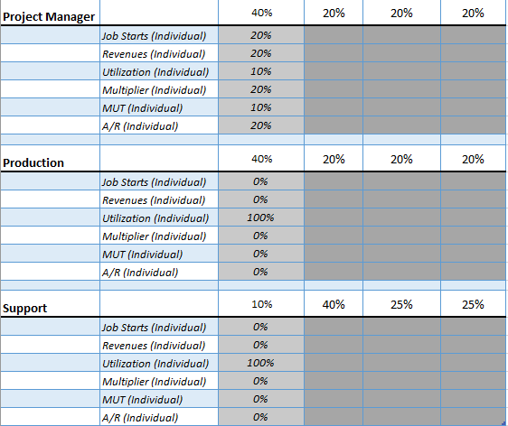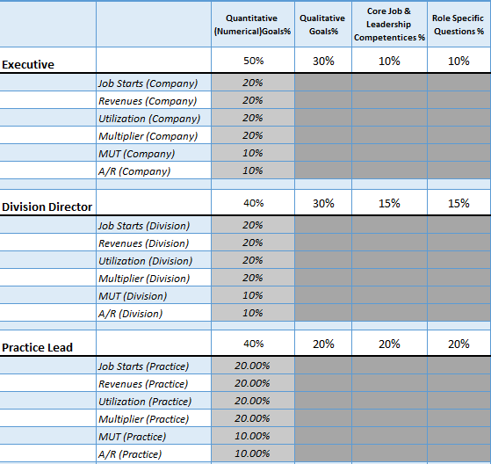

**Performance Ratings**

* There are 3 ratings provided to describe employee performance:

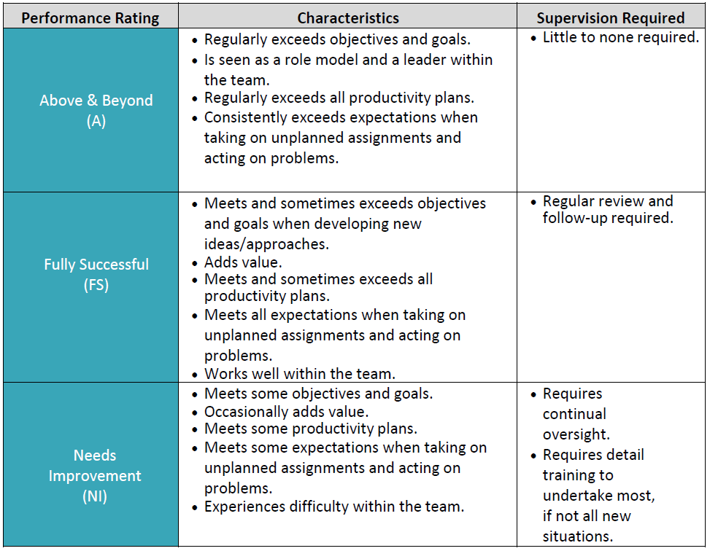

**Above and Beyond:** This rating should only be used in rare circumstances and is reserved for limited instances where outcomes/results are substantially beyond set expectations. Extensive documentation is needed to substantiate the rating.

**Fully Successful:** This rating indicates that the employee is successfully meeting the high standard of the Company.

**Needs Improvement:** This rating indicates the employee is NOT meeting the expectation of the Company for the specific topic area. The assumption is that poor performance has been previously discussed with the employee and will not be an unexpected discussion point. Documentation is required when such a rating is given.

PERFORM Phase: ATGHR for all Users

1. Review

* Click the View Button to begin your review.

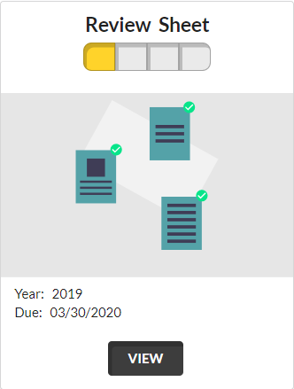

2. Review & Execute Each Tab



* **Goals: Quantitative:** These goals are pulled directly from your Goals.
* **Goals: Qualitative:** These goals are pulled directly from your Goals.
* **Core Job Competencies:** To be completed by all employees.
* **Role Specific Requirements:** Determined by the employee’s role in ATGHR. Contact ATGHR if the Role listed on the Review is incorrect.
* **Questionnaire:** To be completed by all employees

3. Review Tabs

* Respond to all review topics under each Review Tabs.
* Each Review Tab will have one or more Review topics.
* To complete a Review topic, select a rating and place an explanation in the ‘Employee Input’ field, if applicable (Note: If a rating of “Needs Improvement” or “Above and Beyond” is given, an explanation must be provided for a Performance Review to be submitted).

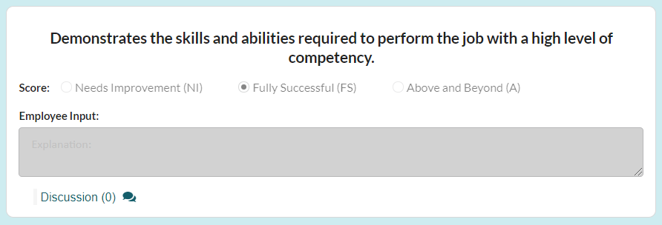f

4. Execute Review

* When an employee completes and submits a self-evaluation, the initial segment in the ‘Progress’ bar will turn green. The supervisor will be notified by email upon the submission.
* There are 3 approvals needed to complete the process: Supervisor> Lead> HR. For each stage of approval, the progress bar will turn green along the chain.
* Once a review Performance Review is approved by HR, a score will be displayed.
* Click “Save” and “Submit”

**Progress:**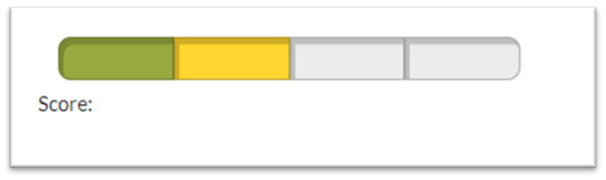

**Complete:**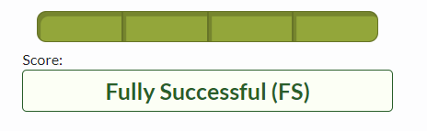

PERFORM Phase: ATGHR for Supervisors and Leads

1. Review

* Click on the “Manage” drop down and select “Reviews”.
* This page will show all performance reviews that you have actionable items on and all approved performance reviews you are able to view. These actionable items include Lead and Manager approvals you need to make to complete your employees’ performance review. Once the PERFORM Phase has begun, goals will be removed from the “Goals” section in the PLAN & PROGRESS phases and are now reflected on an employee’s Performance Review.



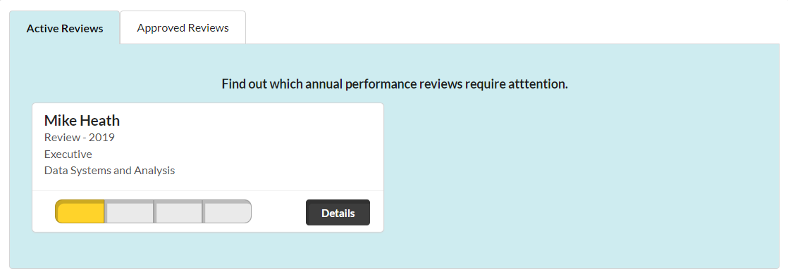

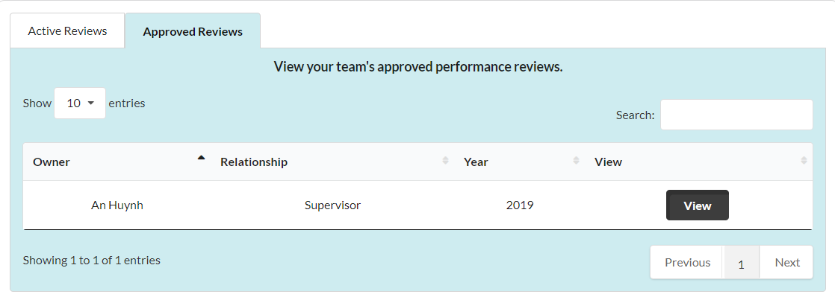

2. Commenting on an Employee’s Review

* If you would like to comment on an employee’s review explanation, click Discussion under the relevant Review topic.



* Click “Add Comment”. A comment box will appear.



* Write your comment in the box and Click “Save”.

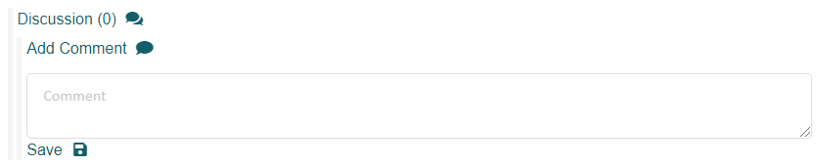

* You and the employee will be able to see and respond to your comment on their review by clicking on the Reply button.

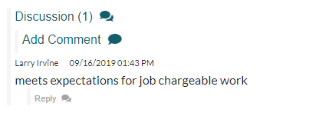

A Comment

* You will also be able to edit and delete your comments from an employee’s review by clicking the Edit and Delete Buttons.
* Note: The page must be refreshed to Edit or Delete a Comment.

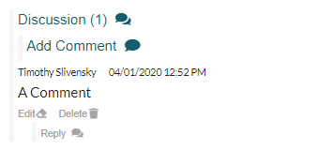

4. Returning an Employee’s Performance Review for Edits

* If you disagree with the performance ratings set by the employee, you may opt to “send back to employee”. When the performance review is sent back, the progress bar goes back to yellow, and the employee will be notified that the review was returned.
* If you have specific reasons for, send a review back to an employee, please provide that information in the relevant ‘Comment’ section.



5. Approving an Employee’s Performance Review

* If you approve of the review, click “Approve (by manager/Lead).” This will move the review to the next level of required approval.



**Resources:**

* [*https://atghr/*](https://atghr/)

**Definitions:**

* **Plan Phase:** Goal setting
* **Progress Phase:** Midpoint check in.
* **Perform Phase:** The formal Annal performance Review. This is completed in five steps.
* **Quantitative:** Numerical goals (including UT, MUT, etc.) that are pre-determined for each employee based upon the company’s annual business plan.
* **Qualitative:** Objective goals specific to the employee, set by the employee.
* **Above and Beyond:** This rating is reserved for *rare* instances where outcomes/results are substantially beyond set expectations. Extensive documentation is needed to substantiate the rating.
* **Fully Successful:** This rating indicates that the employee is successfully meeting the high standard expected by the Company.
* **Needs Improvement:** This rating indicates the employee is NOT meeting the expectation of the Company for the specific topic area. The assumption is that poor performance has been previously discussed with the employee and will not be an unexpected discussion point. Documentation is required when such a rating is given.